**Superior University Faculty of CS & IT**





Project Report

Computer Networks

**Submitted by:** Iqra Khawar

**Submitted to:** Sir Rasikh Ali

**Section:** 5B

**Semester:** 5th

**Submission Deadline:** 10-12-24

**Project:** Superior University Network GUI design and implementation

**Roll no:** su92-bssem-f22-307

**Department of Software Engineering**

**Table of Contents**

Project overview 3

**Building layout of superior university** 3

Connection Devices 3

**Switches:** 3

**Router:** 3

**Server:** 4

**PC’s:** 4

Design 4

Implementation of Network 4

**Dynamic routing (DHCP)** 4

Implementation of dynamic routing for each servers 5

**Command** 5

**Routing Internet Protocol** 7

**Commands** 7

**VLAN** 8

**Inter-VLAN** 8

**Commands** 9

DNS (Domain Name System) 14

**Figure**

Figure 1 4

Figure 2 5

Figure 3 7

Figure 4 11

Figure 5 11

Figure 6 12

# **Project overview**

My project title is **“Superior University, Gold Campus”**. Designing and implementation on cisco packet tracer of that platform. Implemented VLAN, Inter-VLAN, dynamic routing (DHCP) & RIP (Routing Internet Protocol), DNS (Domain Name System) and validation of message passing from one network to another network and from one VLAN to another VLAN.

## **Building layout of superior university**

**Three Floors**:

* **Ground Floor**:

Likely includes an IT room and some labs/offices.

* **First and Second Floors**:

Contain the remaining labs and administrative offices.

**Rooms:**

* **10 Labs**:

For students' practical sessions, requiring robust connectivity and separate VLANs for efficient management.

* **3 Admin Offices**:

These require secure connections for administrative tasks, possibly on a different VLAN.

* **1 IT Room**:

The central point for managing the network, housing core switches, routers, and servers.

# **Connection Devices**

## **Switches:**

Each Labs has only one switch

## **Router:**

Only one router used in the platform.

## **Server:**

Only one server is used in the platform.

## **PC’s:**

Each Lab has 32 Pc’s. Admin Office has three PC’s. Total PC’s are 325.

# **Design**

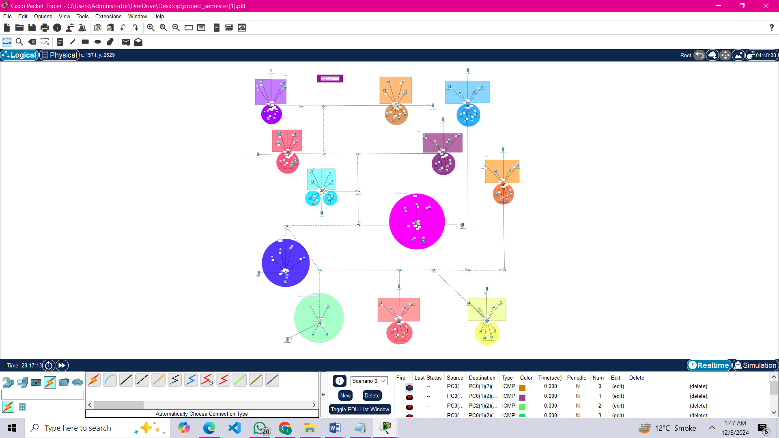

# **Implementation of Network**

## **Dynamic routing (DHCP)**

I’ve have implemented **dynamic routing and DHCP** in your network design, where each network has a dedicated server, and dynamic routing connects all the servers. This approach is efficient and modular, ensuring scalability and seamless communication between networks.

**Design Approach**:

**Servers**:

Placed strategically in each network, handling local traffic and serving as gateways.

**Dynamic Routing**:

Used to interconnect these servers and enable seamless communication across networks.

## Implementation of dynamic routing for each servers

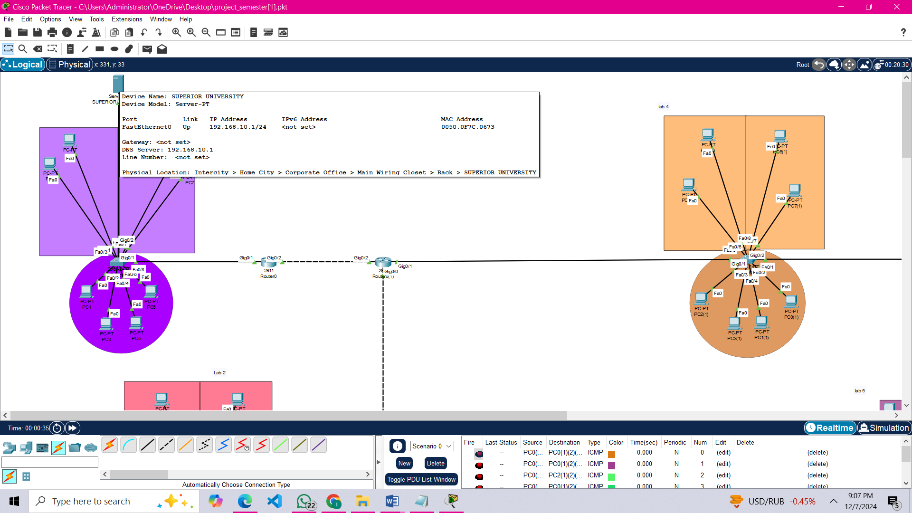

Figure 1

* Assign IP address to each server.
* Assign gateway to each server.
* Assign gateway in DHCP then save and on DHCP.
* Checking all the PCS IP addresses by clicking on DHCP.

### **Command**

DHCP POOL LAB1

ip dhcp pool Lab1

network 192.168.10.0 255.255.255.0

default-router 192.168.10.1

ip dhcp excluded-address 192.168.10.1 192.168.10.10

DHCP POOL LAB2

ip dhcp pool Lab2

network 192.168.12.0 255.255.255.0

default-router 192.168.12.1

ip dhcp excluded-address 192.168.12.1 192.168.12.10

DHCP POOL LAB3

ip dhcp pool Lab3

network 192.168.14.0 255.255.255.0

default-router 192.168.14.1

ip dhcp excluded-address 192.168.14.1 192.168.14.10

DHCP POOL LAB4

ip dhcp pool Lab4

network 192.168.11.0 255.255.255.0

default-router 192.168.11.1

ip dhcp excluded-address 192.168.11.1 192.168.11.10

DHCP POOL LAB5

ip dhcp pool Lab5

network 192.168.13.0 255.255.255.0

default-router 192.168.13.1

ip dhcp excluded-address 192.168.13.1 192.168.13.10

DHCP POOL LAB6

ip dhcp pool Lab6

network 192.168.18.0 255.255.255.0

default-router 192.168.18.1

ip dhcp excluded-address 192.168.18.1 192.168.18.10

DHCP POOL LAB7

ip dhcp pool Lab7

network 192.168.15.0 255.255.255.0

default-router 192.168.19.1

ip dhcp excluded-address 192.168.19.1 192.168.19.10

DHCP POOL LAB8

ip dhcp pool Lab8

network 192.168.21.0 255.255.255.0

default-router 192.168.21.1

ip dhcp excluded-address 192.168.21.1 192.168.21.10

DHCP POOL LAB9

ip dhcp pool Lab9

network 192.168.20.0 255.255.255.0

default-router 192.168.20.1

ip dhcp excluded-address 192.168.20.1 192.168.20.10

## **Routing Internet Protocol**

**Ease of Configuration**: RIP is straightforward to set up and manage.

**Dynamic Updates**: It automatically updates routing tables using periodic broadcasts, reducing manual intervention.

Every **router** connected to the dedicated servers in your network is configured to use RIP.

**RIP** ensures that routers exchange routing tables periodically, sharing information about reachable networks.

### **Commands**

(router-config)#Router rip

(router-config)#network <network address>

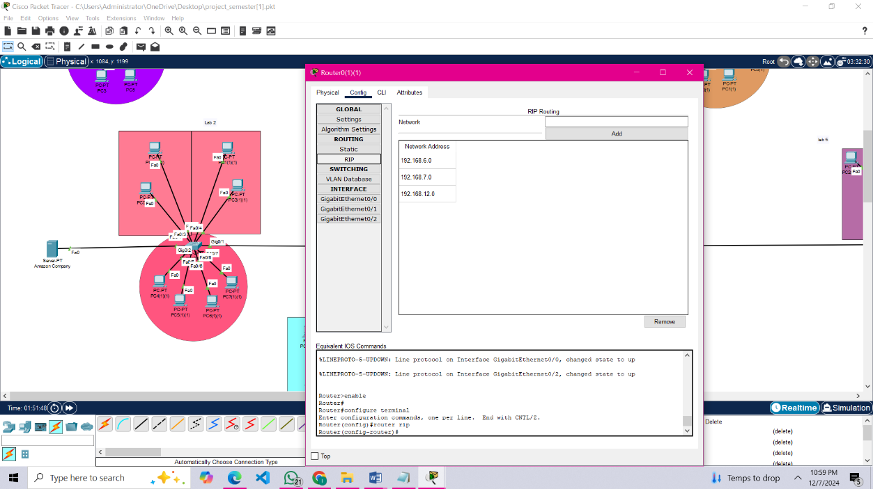

Figure 2

The purpose of routing is to pass data from one network to another network.

## **VLAN**

VLAN stands for Virtual Local Area Network.

**VLAN Implementation:**

1. **Three Networks with VLANs**:

Each of the three networks is logically segmented into different **VLANs**.

VLANs ensure that devices within each network can communicate locally, but are isolated from devices in other VLANs unless explicitly allowed.

1. **Purpose of VLANs**:

**Security**: Traffic is isolated, reducing the risk of unauthorized access.

**Broadcast Control**: Limits broadcast traffic to only devices within the same VLAN, improving efficiency.

**Logical Segmentation**: Allows grouping of devices (labs, admin, IT) regardless of their physical location.

## **Inter-VLAN**

**Inter-VLAN Routing:**

1. **Role of Inter-VLAN Routing**:

Allows communication between VLANs (e.g., for sharing resources like servers or printers across networks).

This is typically configured on a **Layer 3 switch** or a **router**.

1. **Implementation**:

**Router-on-a-Stick**: If using a router, a single physical interface is configured with **subinterfaces**, each representing a VLAN.

**Layer 3 Switch**: Directly performs routing between VLANs, eliminating the need for a router.

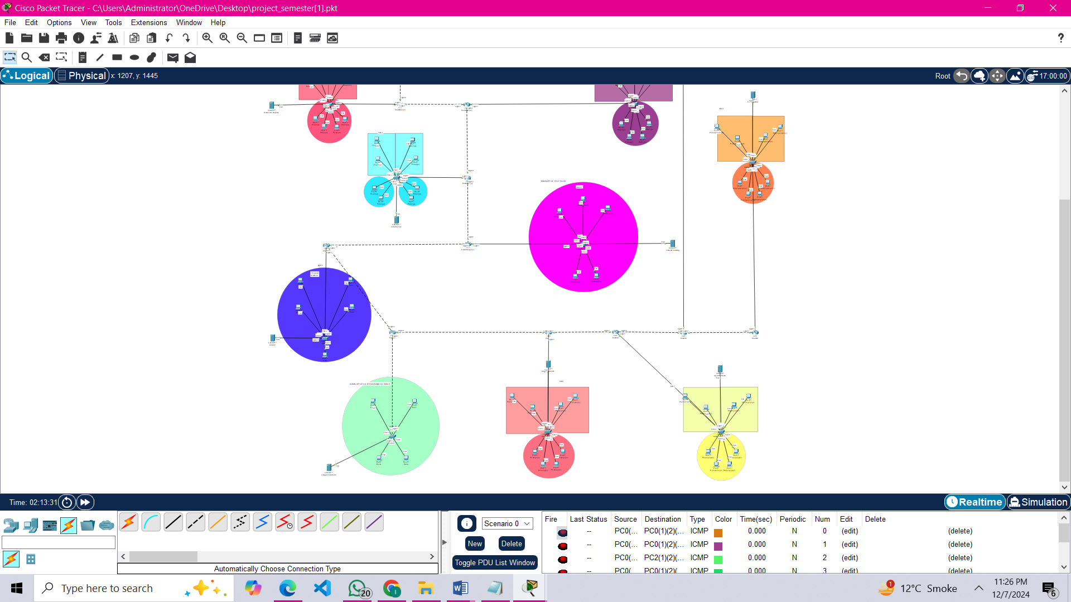

VLAN 30

Figure 3

VLAN 10

VLAN 20

### **Commands**

**Applying VLAN 10, access & trunk ports**

Switch>enable

Switch#config t

Switch(config-t)#vlan 10

Switch(config-t-vlan)#exit

Switch(config-t)#int fa0/3

Switch(config-t)#switchport access vlan 10

Switch(config-t)#switchport access mode

Switch(config-t)#exit

Switch(config-t)#int fa0/1

Switch(config-t)#switchport access vlan 10

Switch(config-t)#switchport access mode

Switch(config-t)#exit

Switch(config-t)#int fa0/5

Switch(config-t)#switchport access vlan 10

Switch(config-t)#switchport access mode

Switch(config-t)#exit

Switch(config-t)#int fa0/4

Switch(config-t)#switchport access vlan 10

Switch(config-t)#switchport access mode

Switch(config-t)#exit

Switch(config-t)#int fa0/8

Switch(config-t)#switchport access vlan 10

Switch(config-t)#switchport access mode

Switch(config-t)#exit

Switch(config-t)#int gig0/1

Switch(config-t)#no shutdown

Switch(config-t)#switchport access trunk

Switch(config-t)#exit

**Applying encapsulation on router (vlan 10)**

router(config-t)#int gig0/1.10

router(config-t)#encapsulation dot1Q vlan 10

router(config-t)#ip address 192.168.15.1 255.255.255.0

router(config-t)#exit

**Applying VLAN 20, access & trunk ports**

Switch>enable

Switch#config t

Switch(config-t)#vlan 20

Switch(config-t-vlan)#exit

Switch(config-t)#int fa0/1

Switch(config-t)#switchport access vlan 20

Switch(config-t)#switchport access mode

Switch(config-t)#exit

Switch(config-t)#int fa0/3

Switch(config-t)#switchport access vlan 20

Switch(config-t)#switchport access mode

Switch(config-t)#exit

Switch(config-t)#int fa0/5

Switch(config-t)#switchport access vlan 20

Switch(config-t)#switchport access mode

Switch(config-t)#exit

Switch(config-t)#int fa0/6

Switch(config-t)#switchport access vlan 20

Switch(config-t)#switchport access mode

Switch(config-t)#exit

Switch(config-t)#int gig0/1

Switch(config-t)#no shutdown

Switch(config-t)#switchport access trunk

Switch(config-t)#exit

**Applying encapsulation on router (vlan 10)**

router(config-t)#int gig0/1.20

router(config-t)#encapsulation dot1Q vlan 20

router(config-t)#ip address 192.168.17.1 255.255.255.0

router(config-t)#exit

**Applying VLAN 30, access & trunk ports**

Switch>enable

Switch#config t

Switch(config-t)#vlan 30

Switch(config-t-vlan)#exit

Switch(config-t)#int fa0/2

Switch(config-t)#switchport access vlan 30

Switch(config-t)#switchport access mode

Switch(config-t)#exit

Switch(config-t)#int fa0/3

Switch(config-t)#switchport access vlan 30

Switch(config-t)#switchport access mode

Switch(config-t)#exit

Switch(config-t)#int fa0/1

Switch(config-t)#switchport access vlan 30

Switch(config-t)#switchport access mode

Switch(config-t)#exit

Switch(config-t)#int fa0/4

Switch(config-t)#switchport access vlan 30

Switch(config-t)#switchport access mode

Switch(config-t)#exit

Switch(config-t)#int fa0/5

Switch(config-t)#switchport access vlan 30

Switch(config-t)#switchport access mode

Switch(config-t)#exit

Switch(config-t)#int gig0/1

Switch(config-t)#no shutdown

Switch(config-t)#switchport access trunk

Switch(config-t)#exit

**Applying encapsulation on router (vlan 30)**

router(config-t)#int gig0/1.30

router(config-t)#encapsulation dot1Q vlan 30

router(config-t)#ip address 192.168.16.1 255.255.255.0

router(config-t)#exit

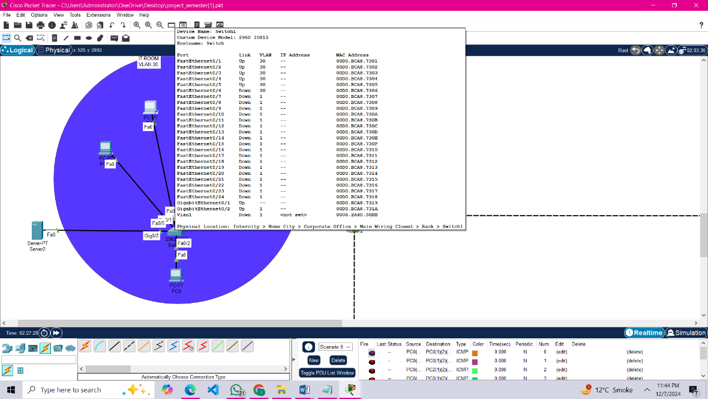

Figure 4

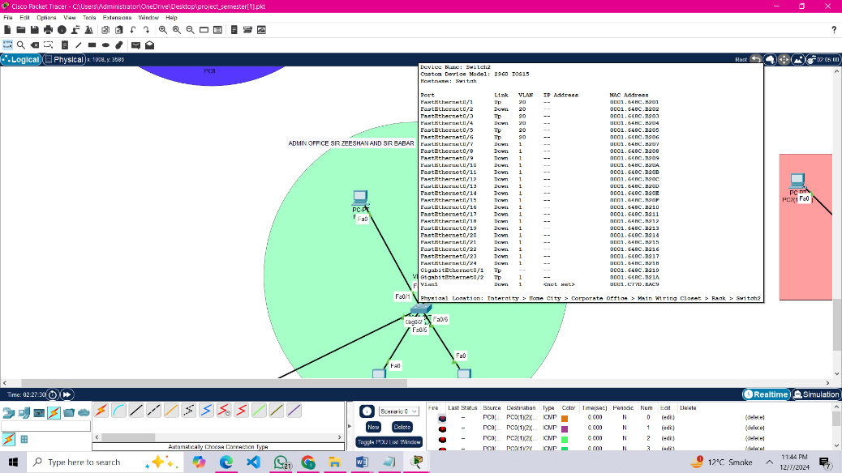

Figure 5

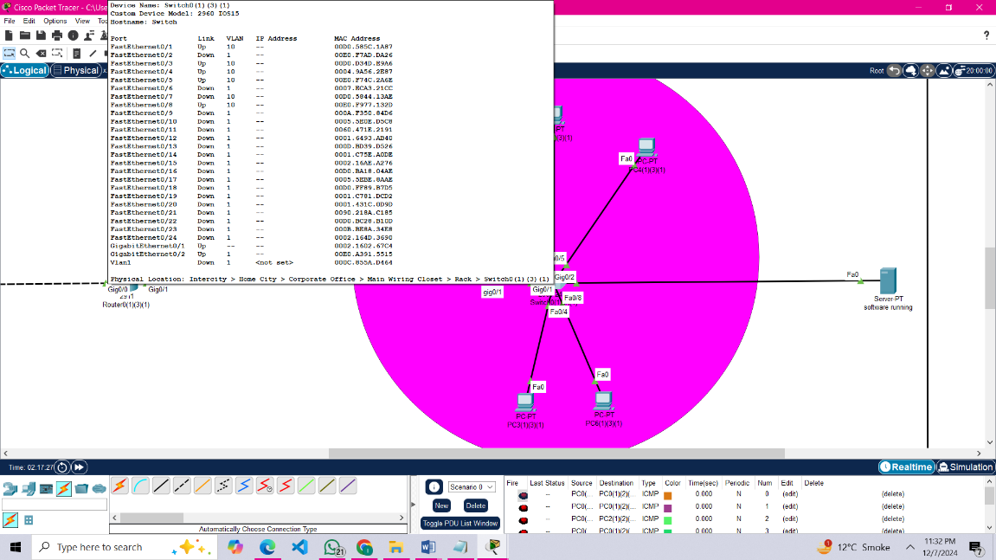

Figure 6

## DNS (Domain Name System)

**DNS Implementation in Your Server:**

1. **Purpose of DNS**:

Translates **domain names** (e.g., lab1.superior.edu) into **IP addresses** (e.g., 192.168.10.5) and vice versa.

Makes it easier for users to access resources without remembering IP addresses.

1. **DNS Server Role**:

Acts as the central point for resolving names in your network.

Can be configured to handle both **internal domain names** (e.g., lab networks, admin systems) and **external domain names** (e.g., internet access).

1. **Integration with DHCP**:

**DHCP server** assigns IP addresses to devices, and the DNS server resolves the corresponding names.

The DHCP server can be configured to automatically update the DNS server with assigned hostnames and IPs. 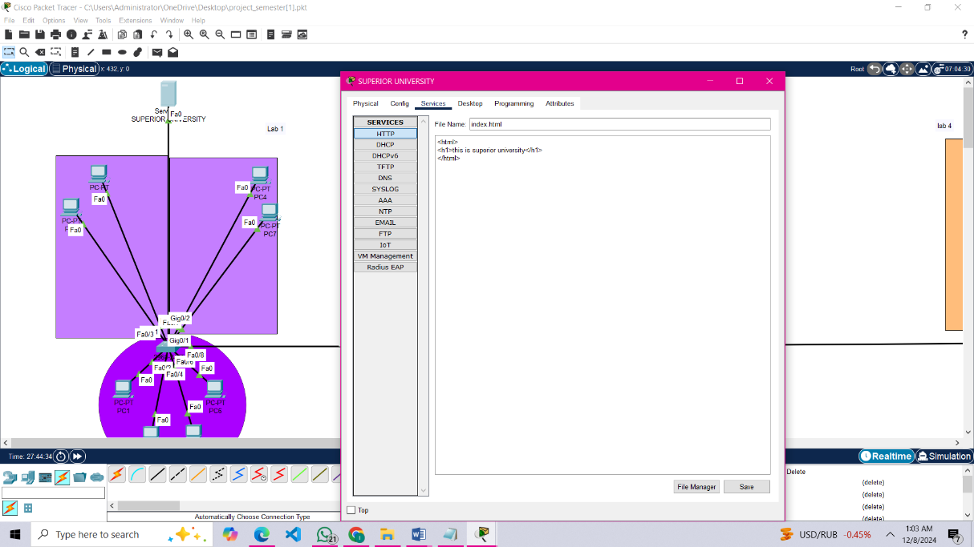

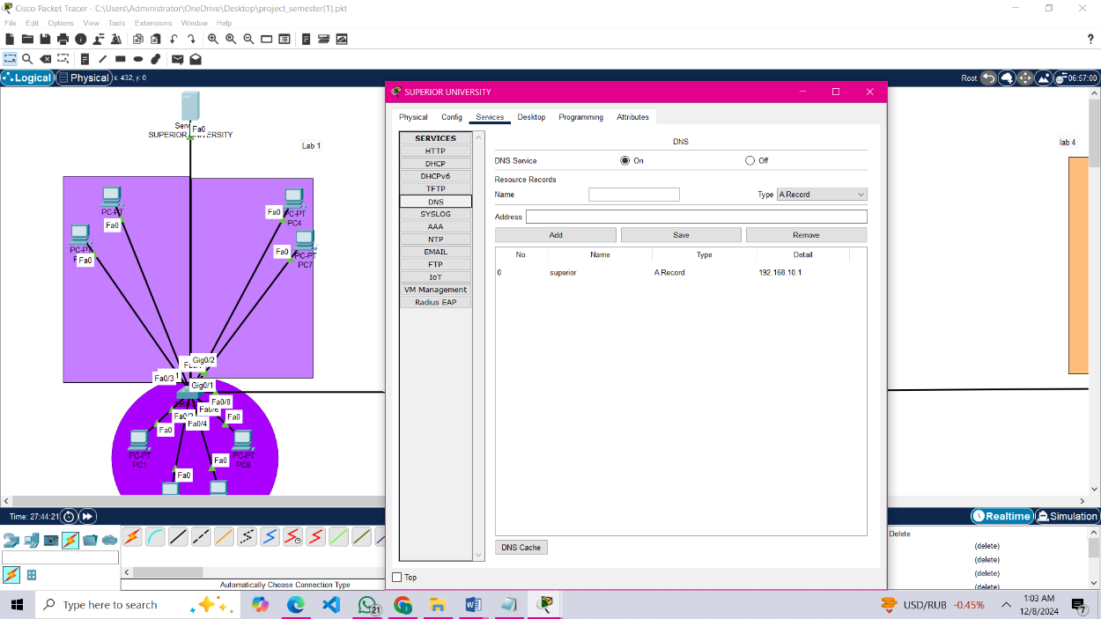

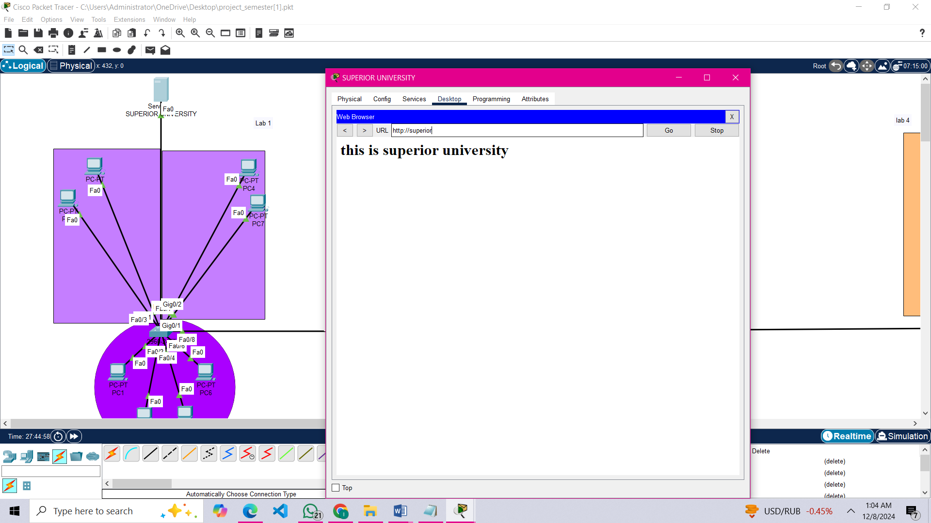

***DNS applied on all servers.***